

ICT1002

**Digital Crime Analyser**

Team 29 - User’s Guide

**SOFTWARE DESCRIPTION** **3**

Description 3

Benefits and Value 3

**Importing of dataset** **4**

**Filtering search data** **6**

**Prediction of attacks** **7**

**Generating graphical displays** **8**

**Exporting of dataset** **10**

# 

# 

# 

# 

# 

# 

# SOFTWARE DESCRIPTION

## Description

The software will analyse datasets as well as extract them into a new format that will better help crime investigators. It can also display statistical data which can give a better visualization for the user.

## Benefits and Value

The investigators can better determine what attack has occurred according to the data. It can also give a better understanding of how and what preparation measures to take towards future attacks.

# 

# Importing of dataset

1. Click the “Browse A File” button.

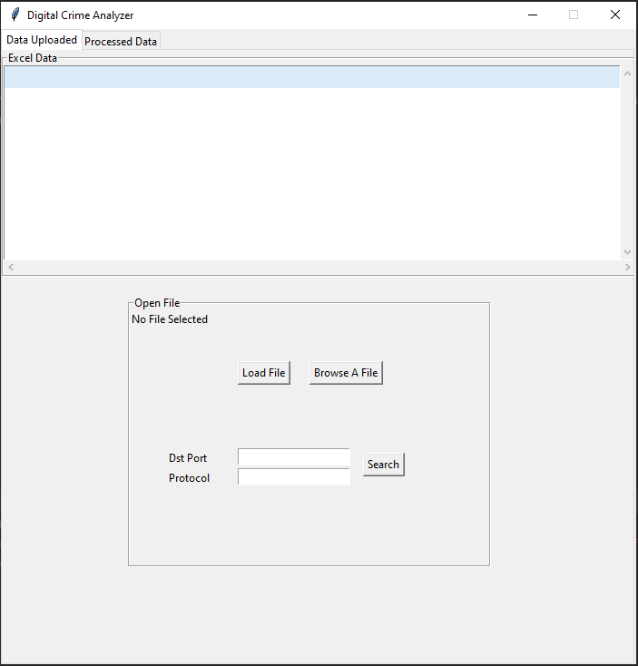

1. A prompt will appear for users to select their dataset. Only in .csv file format is allowed. Users will have to click on ‘Open’ once they have selected their file. **(Use provided dataset located in “Sample Data/Final Dataset.csv”)**

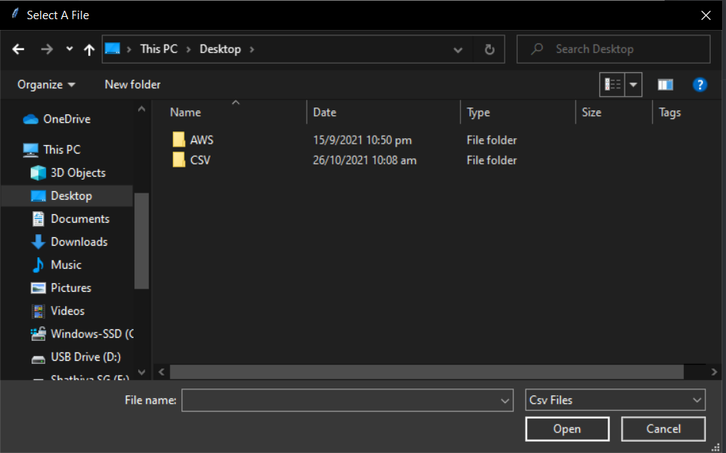

1. Click the “Load File” button.

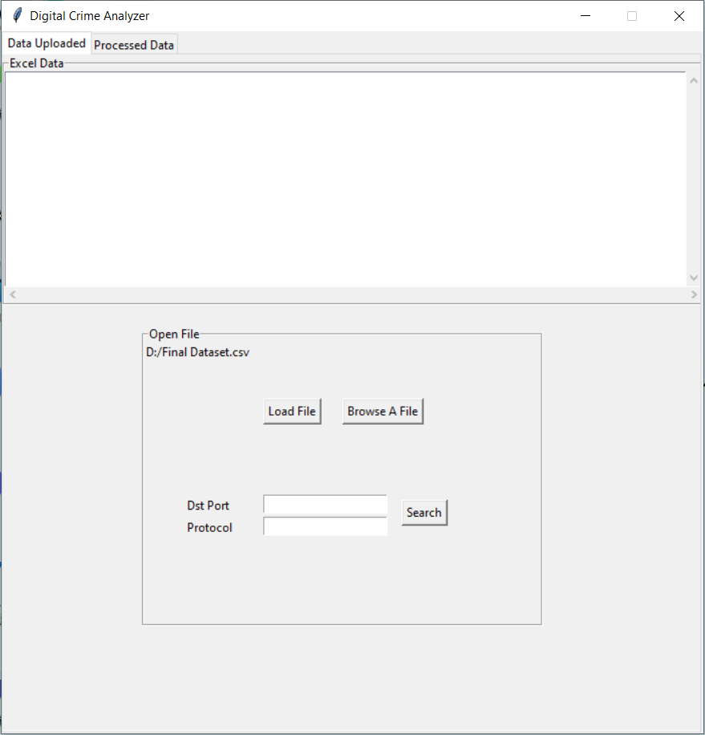

1. The file will be loaded and values will appear under ‘Excel Data’

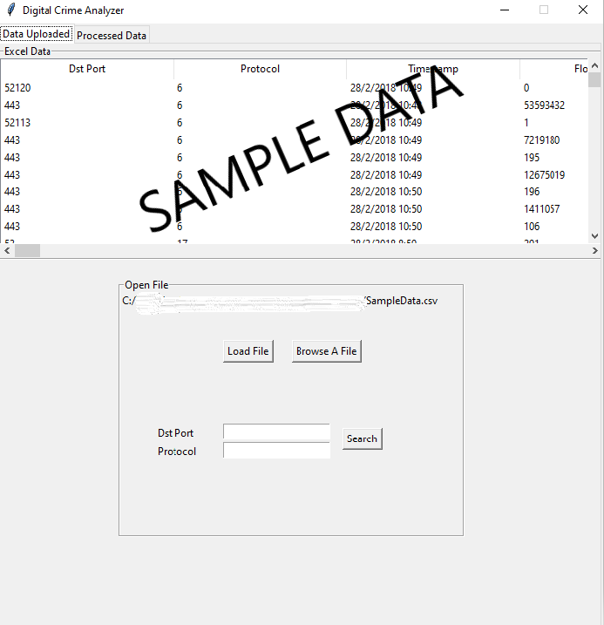

# Filtering search data

1. The user can enter a value for “Destination port”, “Protocol” or both

1. The values in the ‘Excel Data’ table will be updated when the search button is clicked

# Prediction of attacks

The prediction model is created using machine learning, and it predicts the type of attack based on the dataset.

Prediction Output

# 

# Generating graphical displays

1. Users can click on Bar Graph, Pie Chart, and Donut

1. A bar graph data will be shown

Bar Graph

Donut Chart

Pie Chart

# 

# Exporting of dataset

1. From the Processed Data tab, click the “Export File” button.

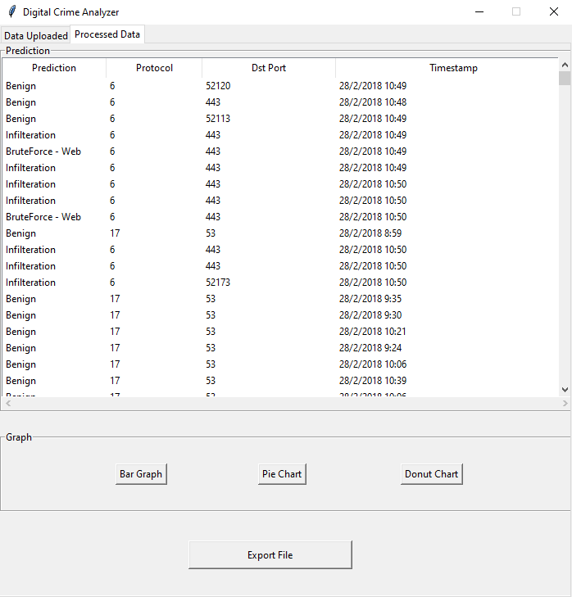

1. Input file name and save file at the desired location.

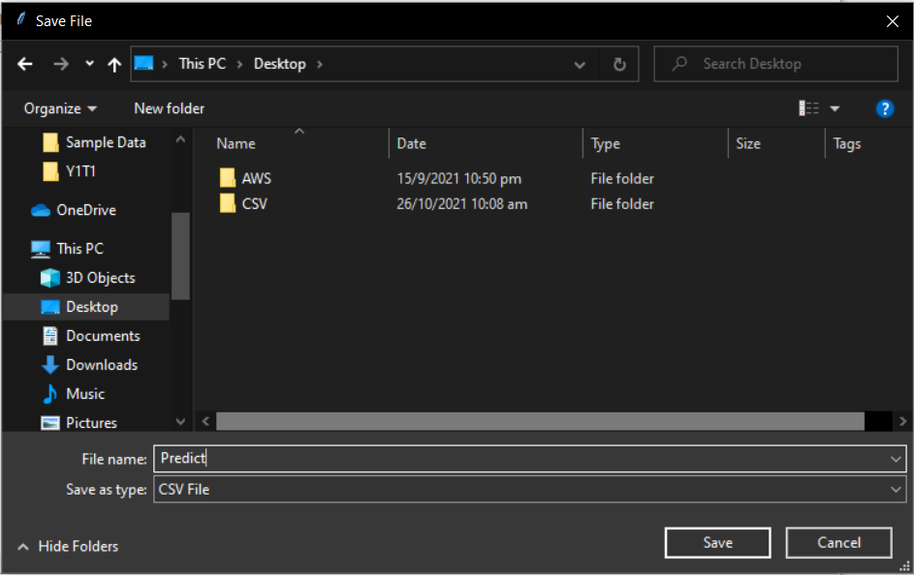

1. CSV file has been created and the data is shown below

1. The User can save the graphical displays by clicking on the save iconic at the bottom

1. The user can select the location they want to save the file

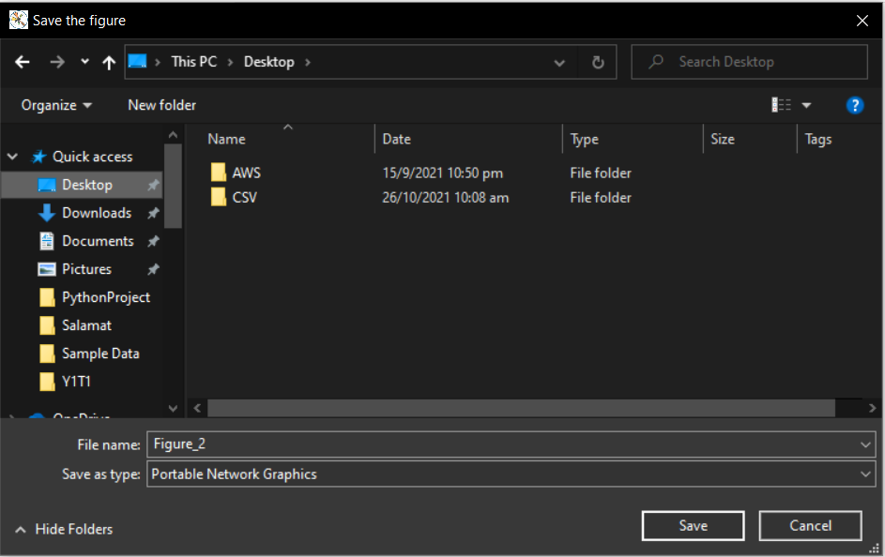

1. The user can view it in their own photo viewer software

